HARJOITUS 6

6.1
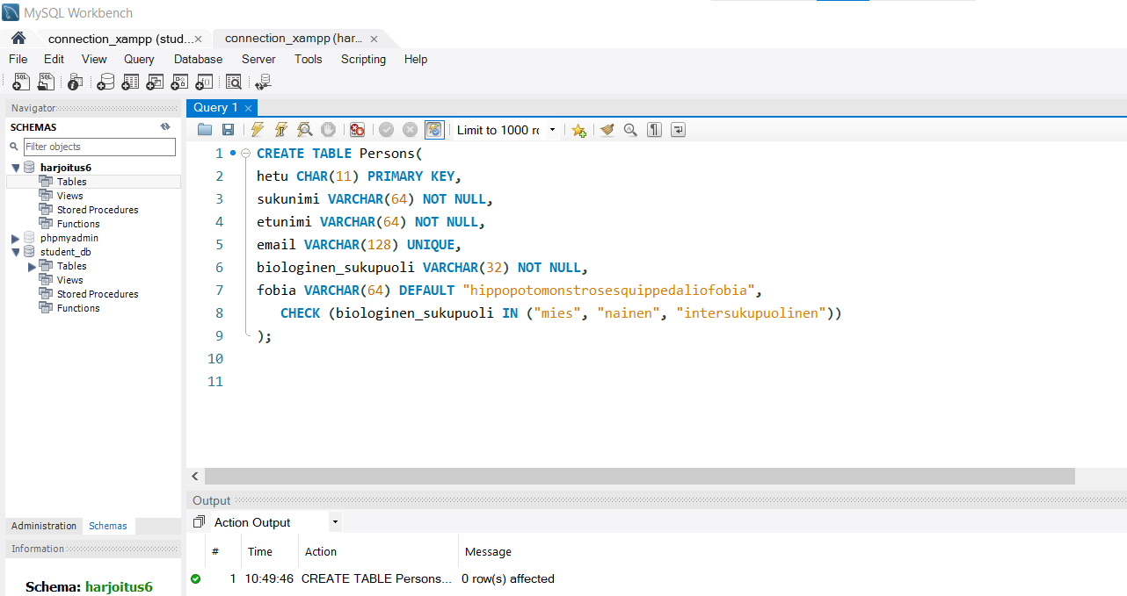

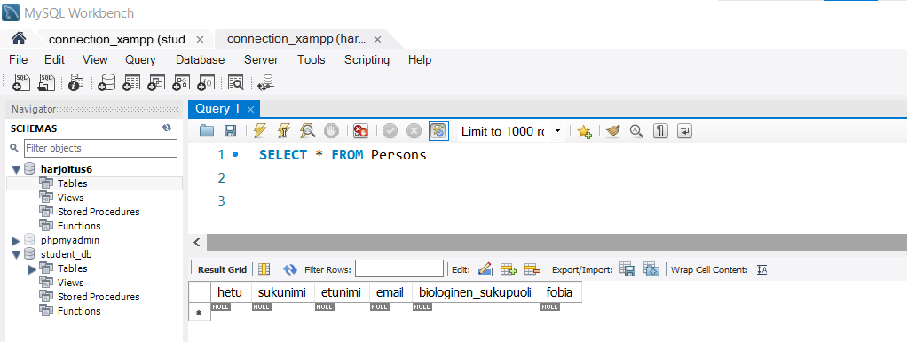

6.2
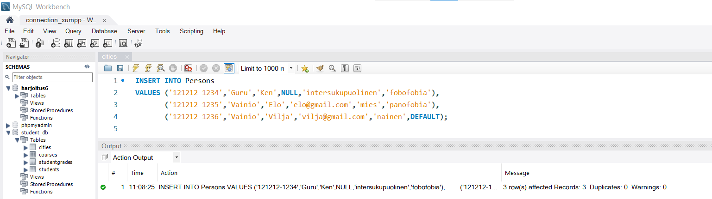
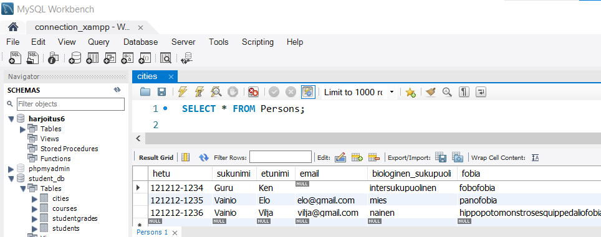

*Here I have used a trigger to display the error since the error couldn’t be displayed.
DELIMITER $$
CREATE TRIGGER trigger1
BEFORE INSERT ON persons
FOR EACH ROW
BEGIN
IF !(NEW.biologinen_sukupuoli IN ('mies','nainen','intersukupuolinen')) THEN
CALL `Error: wrong gender`;
END IF;
END$$

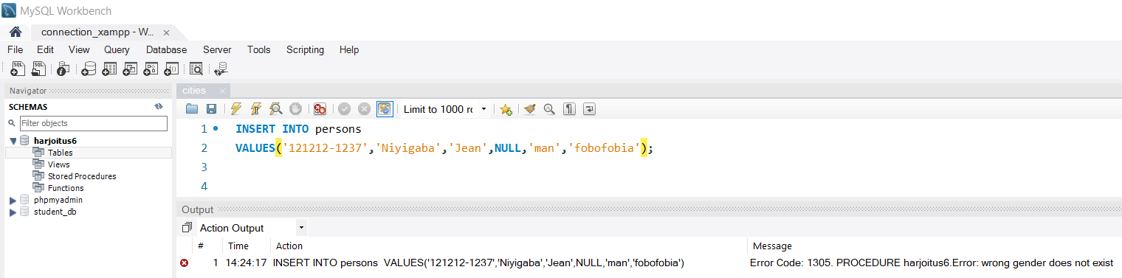

*This task has worked without the use of triggers
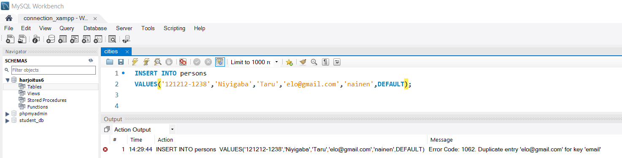

*This task has been completed with the help of a trigger
DELIMITER $$
CREATE TRIGGER trigger2
BEFORE INSERT ON persons
FOR EACH ROW
BEGIN
IF !(NEW.hetu <=11) THEN
CALL `Error: Too long hetu !`;
END IF;
END$$

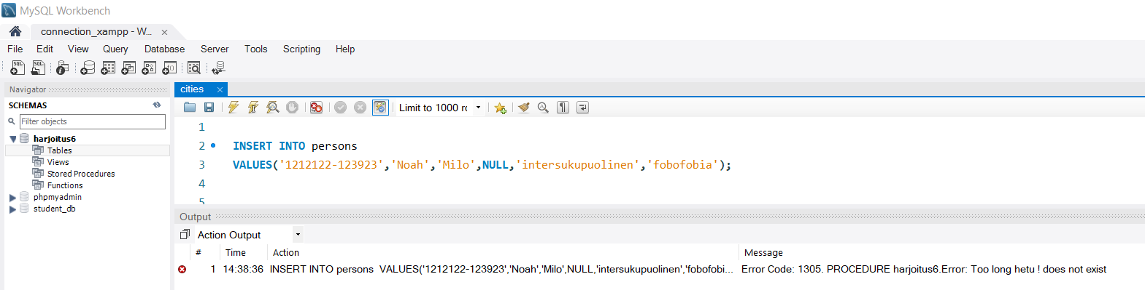

6.3
